555 TIMER

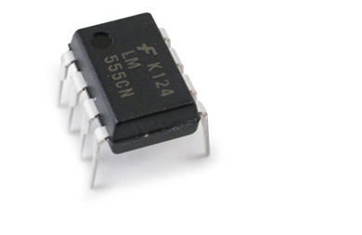

555 is a very commonly used IC for generating accurate timing pulses. It is an 8pin timer IC and has mainly two modes of operation: monostable and astable. In monostable mode time delay of the pulses can be precisely controlled by an external resistor and a capacitor whereas in astable mode the frequency & duty cycle are controlled by two external resistors and a capacitor.
Pin Diagram:
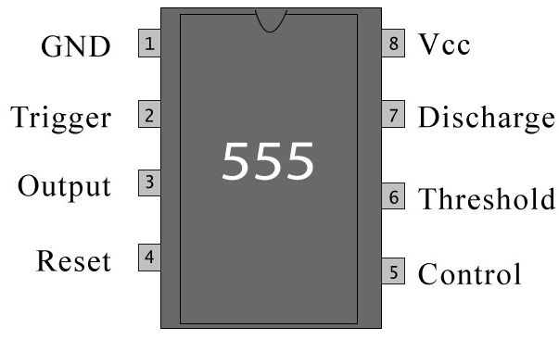

Pin Description:

Pin No | Function | Name
1 | Ground (0V) | Ground
2 | Voltage below 1/3 Vcc to trigger the pulse | Trigger
3 | Pulsating output | Output
4 | Active low; interrupts the timing interval at Output | Reset
5 | Provides access to the internal voltage divider; default 2/3 Vcc | Control Voltage
6 | The pulse ends when the voltage is greater than Control | Threshold
7 | Open collector output; to discharge the capacitor | Discharge
8 | Supply voltage; 5V (4.5V - 16 V) | Vcc

The 555 Timer IC is an integrated circuit (chip) implementing a variety of timer and multivibrator applications. The IC was designed by Hans R. Camenzind in 1970 and brought to market in 1971 by Signetics (later acquired by Philips). The original name was the SE555 (metal can)/NE555 (plastic DIP) and the part was described as "The IC Time Machine". It has been claimed that the 555 gets its name from the three 5 kΩ resistors used in typical early implementations,but Hans Camenzind has stated that the number was arbitrary. The part is still in wide use, thanks to its ease of use, low price and good stability. As of 2003, it is estimated that 1 billion units are manufactured every year.
Depending on the manufacturer, the standard 555 package includes over 20 transistors, 2 diodes and 15 resistors on a silicon chip installed in an 8-pin mini dual-in-line package (DIP-8).Variants available include the 556 (a 14-pin DIP combining two 555s on one chip), and the 558 (a 16-pin DIP combining four slightly modified 555s with DIS & THR connected internally, and TR falling edge sensitive instead of level sensitive).
Ultra-low power versions of the 555 are also available, such as the 7555 and TLC555. The 7555 is designed to cause less supply glitching than the classic 555 and the manufacturer claims that it usually does not require a "control" capacitor and in many cases does not require a power supply bypass capacitor.
The 555 has three operating modes:

Monostable mode: in this mode, the 555 functions as a "one-shot". Applications include timers, missing pulse detection, bounce free switches, touch switches, frequency divider, capacitance measurement, pulse-width modulation (PWM) etc
Astable - free running mode: the 555 can operate as an oscillator. Uses include LED and lamp flashers, pulse generation, logic clocks, tone generation, security alarms, pulse position modulation, etc.
Bistable mode or Schmitt trigger: the 555 can operate as a flip-flop, if the DIS pin is not connected and no capacitor is used. Uses include bounce free latched switches, etc.
Pin connections:

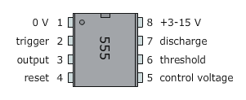

The 555 timer is an extremely versatile integrated circuit which can be used to build lots of different circuits. You can use the 555 effectively without understanding the function of each pin in detail.
Frequently, the 555 is used in astable mode to generate a continuous series of pulses, but you can also use the 555 to make a one-shot or monostable circuit. The 555 can source or sink 200 mA of output current, and is capable of driving wide range of output devices.
Specifications:

These specifications apply to the NE555. Other 555 timers can have different specifications depending on the grade (military, medical, etc).
- Supply voltage (V_{CC}) | 4.5 to 15 V
- Supply current (V_{CC} = +5 V) | 3 to 6 mA
- Supply current (V_{CC} = +15 V) | 10 to 15 mA
- Output current (maximum) | 200 mA
- Maximum Power dissipation | 600 mW
- Power Consumption (minimum operating) |  | 30 mW@5V, 225 mW@15V
- Operating temperature | 0 to 70 °C

